**­**

**Project Report**

**(Bank Management System)**

**Submitted To: Mam IQRA BISHARAT**

**_______________________________________________________________________________________________________________________________________________________________________________________________________________________________________**

**Student Name: FARAZ HUSSAIN 01-134182-100**

**SHOAIB ADIL 01-134182-039**

**FAISAL AMEER 01-134182-093**

**_______________________________________________________________________________________________________________________________________________________________________________________________________________________________________**

**Enrolment No: 01-134182-100**

**01-134182-039**

**01-134182-093**

**_______________________________________________________________________________________________________________________________________________________________________________________________________________________________________**

* **Abstract (One page)**

The program named, “Bank Management System”.

Bank management system can be considered as a most important thing in economic world.in the present scenario the banking sector is the common need in everyday life.

As we are beginners and have no practical experience in the field of software development and moreover the Banking System is very wide. So, we limit the scope of our project by computerizing the following fields of the Banking System:

We made two sections, the one is admin and the other one is user.

The Admin, helps to create the employee account and deleting a employee account.

The user can view account details, update the information, deposit the amount as much as he want and withdraw the amount.

* **Introduction (one page)**

The main objective of the project is to develop online Banking system for banks. In present system all banking work is done manually. User have to visit bank to  Withdrawal or Deposit amount. In present bank system it is also difficult to find account information of account holder. In this bank management system we will automate all the banking process. In our bank management system user can check his balance online and he can also transfer money to other account online. In this Software you can keep record for daily Banking transactions. The main purpose of developing bank management system is to design an application, which could store bank  data and provide an interface for retrieving customer related details with 100% accuracy.

* This bank management system also allow user to add new customer account, delete account and user can also modify existing user account information. Using this system user can also search any individual account in few seconds. Using our bank management system user can also check any translation in any account. User can deposit the amount as much as he want in the account but first he needs to enter the ISBN number and Pin ,and same is the case of withdraw. But minimum amount of withdraw is five hundred rupees.

**Project Details:**

The Project Banking system has been made to automate the Banking system. Through this bank management system user can manage all bank account activity like deposit money, withdraw money, user can check his account detail online like balance in account, bank statement etc. This system is also help bank user to create New account easily. And whenever u want to delete you can delete an account easily. The project makes a sincere effort to provide all the below-mentioned features to meet the requirements of the bank. Using this bank management system any information can be easily searched. User can view all the details of the customer. Manage large number of customer details with ease. The proposed system provides faster data access, data entry and retrieval.

The proposed system is more efficient, fast, reliable, user friendly. Over and above the proposed system does not have any possibility of data loss during processing.

* **Main features of Project ()**
* **Admin:**

This function is used to add a new account and

delete an account.

* **User**:

In user function we can update an employee details like change the phone number, change the address or change the pin number. In user function we can also deposit the amount as uch as we want and withdraw the amount .minimum amount of withdraw is rupees 500.

* **Topics of Subject Covered in Project**

The topics covered are as followed

* Linked list

1. Insertion

2. Deletion at specific position

3. Display

* Loops
* Functions
* **Screen Shots of Project (at least 4)**

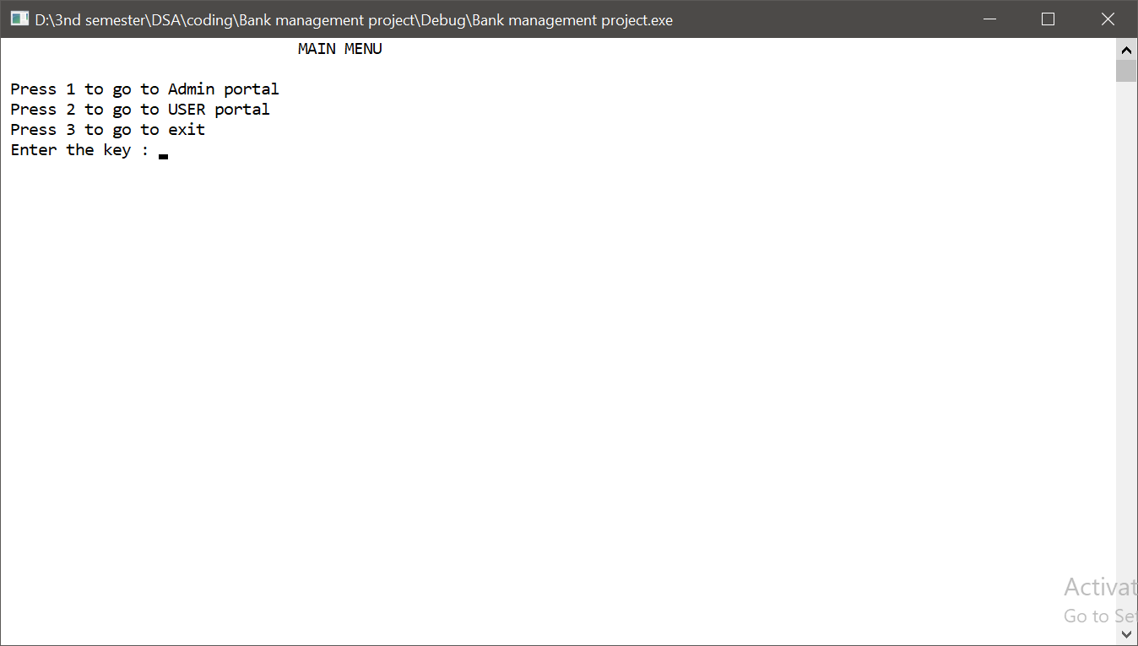

**//admin login**

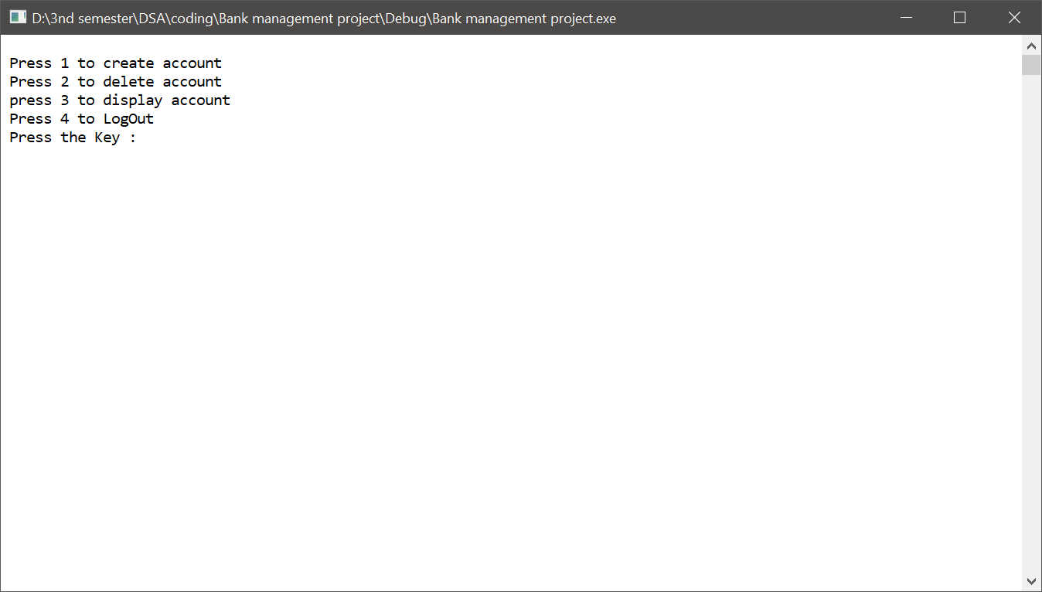

**//create account**

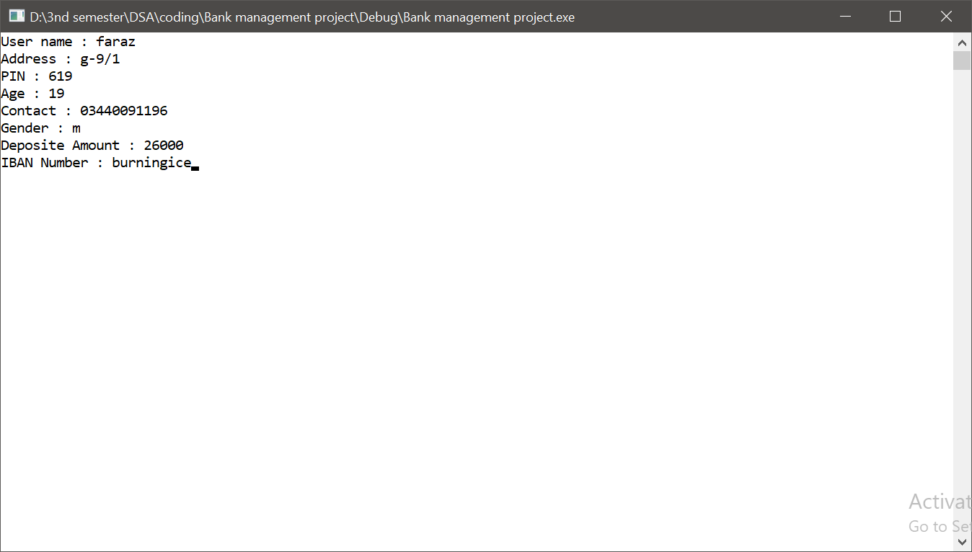

**//display acount**

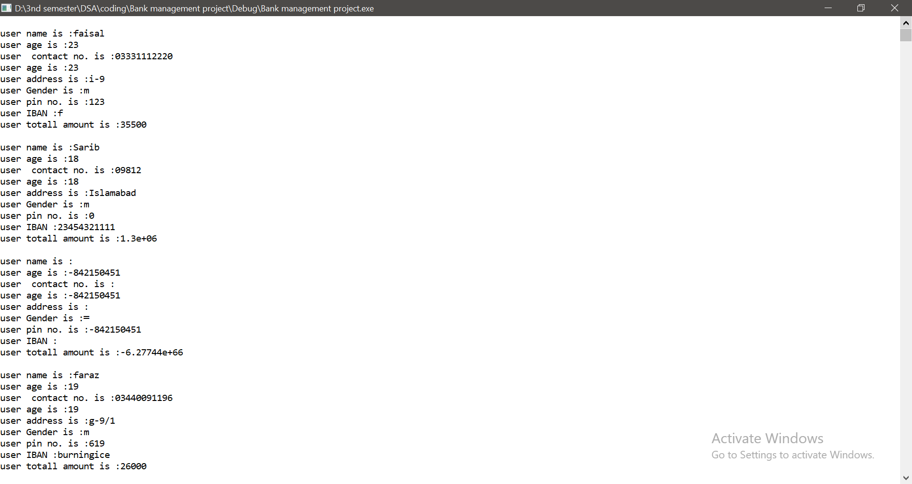

**//Delete account**

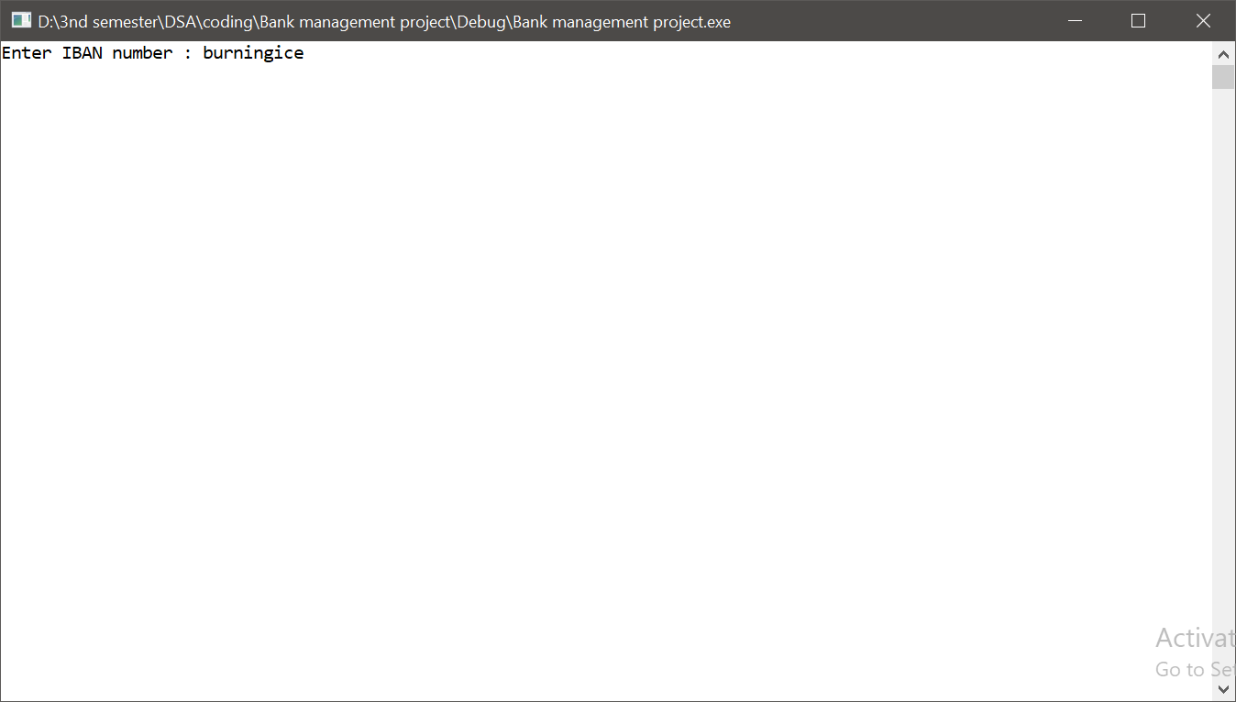

**//user portal**

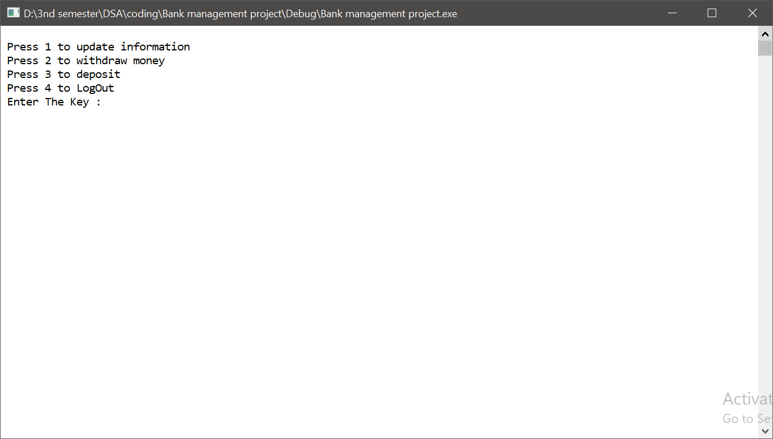

**//deposit and withdraw**

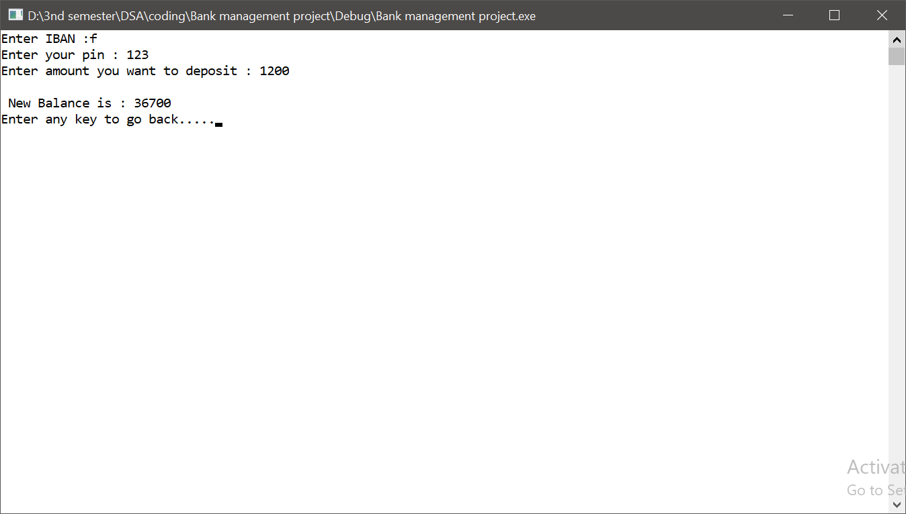

* **Main Algo and Code of Project**

#include<iostream>

#include<conio.h>

#include<string>

#include<fstream>

#include<Windows.h>

using namespace std;

struct NODE

{

string name;

int age;

string address;

char gender;

string pNumber;

int pin;

string IBAN;

double ammount;

NODE *next;

} *head = NULL, *tail = NULL;

class Admin {

public:

//THIS FUNTION ADDS NEW USERS TO THE LIST

void addUser(NODE *u)

{

if (head == NULL)

{

head = tail = u;

u->next = NULL;

}

else

{

tail->next = u;

u->next = NULL;

tail = u;

}

}

//THIS FUNCTION DISPLAY THE ACCOUNT OF USERS IN DATABASE

void display()

{

system("cls");

if (head == NULL)

{

cout << "\n LIST IS EMPTY";

}

else

{

NODE *temp = new NODE;

temp = head;

while (temp != NULL)

{

cout << "user name is :" << temp->name << "\n";

cout << "user age is :" << temp->age << "\n";

cout << "user contact no. is :" << temp->pNumber << "\n";

cout << "user age is :" << temp->age << "\n";

cout << "user address is :" << temp->address << "\n";

cout << "user Gender is :" << temp->gender << "\n";

cout << "user pin no. is :" << temp->pin << "\n";

cout << "user IBAN :" << temp->IBAN << "\n";

cout << "user totall amount is :" << temp->ammount << "\n";

temp = temp->next;

cout << "\n";

}

}

_getch();

}

//THIS FUNCTION CAN DELETE THE USER ACCOUNT FROM BANK DATABASE

//ONLY ADMIN HAS THIS PERMISSION

void deleteAccount(string accountNumber) {

NODE *temp = head;

if (accountNumber == head->IBAN) {

head = head->next;

return;

}

else {

while (temp != tail)

{

if (temp->next->IBAN == accountNumber)

{

temp->next = temp->next->next;

if (temp->next == NULL)

{

tail = temp;

}

return;

}

temp = temp->next;

}

cout << "\n Account Number Does Not Exist";

}

}

};

class user {

public:

//USER CAn UPDATE HIS THAT FROM HERE

//ONLY SOME OF THE DATA CAN BE CHANGED

void updateInfo()

{

int pi;

string in;

cout << "ENTER YOUR ISBN NUMBER :";

cin >> in;

cout << "ENTER YOUR PIN :";

cin >> pi;

NODE *temp = head;

while (temp != NULL) {

if (temp->IBAN == in && temp->pin == pi) {

break;

}

temp = temp->next;

}

if (temp == NULL)

{

cout << "\n IBAN number or PIN is incorrect";

return;

}

fstream fout("queue.txt", ios::app);

int opt;

do

{

cout << "\n press 1 to update address.. ";

cout << "\n press 2 to update phone number..";

cout << "\n press 3 to update PIN..";

cout << " \n press 4 to go back..";

cout << "\n Enter your choice : ";

cin >> opt;

switch (opt)

{

case 1:

{

cout << "\n Enter You Updated Address : ";

cin >> temp->address;

cout << endl;

break;

}

case 2:

{

cout << "\n Enter You Updated Phone Number : ";

cin >> temp->pNumber;

cout << endl;

break;

}

case 3:

{

cout << "\n Enter You New PIN : ";

int p;

cin >> p;

cout << "\n Enter You PIN to Comfirm : ";

cin >> temp->pin;

if (p != temp->pin)

{

cout << "\n PIN dose not MATCH";

}

cout << endl;

break;

}

default:

{

cout << "\n Enter Correct Option";

cout << endl;

break;

}

}

} while (opt != 4);

}

//USER CAN WITHDRAW CASH FROM HIS ACCOUNT

//BUT USER HAVE TO ENTER HIS IBAN

//AND PASSWORD

void withdraw()

{

NODE *temp = head;

int ammount;

string ibn;

int pin;

cout << "Enter IBAN :";

cin >> ibn;

while (temp != NULL)

{

if (temp->IBAN == ibn)

{

l:

cout << "Enter your pin : ";

cin >> pin;

if (temp->pin == pin)

{

l1:

cout << "ENTER YOUR AMMOUNT TO WITHDRAW";

cin >> ammount;

if ((ammount % 500) != 0)

{

cout << "enter some appropriate amount" << endl;

system("pause");

goto l1;

}

if (temp->ammount < ammount)

{

cout << "the amount exceeds the limit" << endl;

system("pause");

goto l1;

}

else

{

temp->ammount -= ammount;

cout << "\nAmmount Remaning in Account : " << temp->ammount;

cout << "\n";

cout << "Enter any key to go back.....";

}

}

else

{

cout << "Pin mismatch.." << endl;

cout << "Can't withdraw.." << endl;

system("pause");

goto l;

}

}

temp = temp->next;

}

_getch();

}

//USER CAN WITHDRAW CASH FROM HIS ACCOUNT

//BUT USER HAVE TO ENTER HIS IBAN

//AND PASSWORD

void deposite()

{

NODE *temp = head;

int amountdeposite, Pin;

string Di;

cout << "Enter IBAN :";

cin >> Di;

while (temp != NULL)

{

if (temp->IBAN == Di)

{

cout << "Enter your pin : ";

cin >> Pin;

if (temp->pin == Pin)

{

cout << "Enter amount you want to deposit : ";

cin >> amountdeposite;

temp->ammount += amountdeposite;

cout << "\n New Balance is : " << temp->ammount;

cout << "\n";

cout << "Enter any key to go back.....";

}

else

{

cout << "Pin mismatch.." << endl;

cout << "Can't deposite.." << endl;

system("pause");

}

}

temp = temp->next;

}

_getch();

}

};

void intro()

{

cout << "\t\t\t\tMAIN MENU" << endl;

cout << "\n Press 1 to go to Admin portal";

cout << "\n Press 2 to go to USER portal";

cout << "\n Press 3 to go to exit ";

}

int main()

{

//introduction

system("cls");

cout << "\n\n\n\n\t\t\t";

for (int i = 0; i < 28; i++)

{

Sleep(60);

cout << "*";

}

cout << "\n\t\t\t** ";

Sleep(100);

cout << "BANK ";

Sleep(100);

cout << "MANAGEMENT";

Sleep(100);

cout << " SYSTEM ";

cout << "**";

cout << "\n\t\t\t";

for (int i = 0; i < 28; i++)

{

Sleep(60);

cout << "*";

}

Sleep(600);

cout << "\n\n\n\t\t\tDeveloped By:";

Sleep(1000);

cout << endl << endl << endl;

cout << "\t\t\tNAME\tFaraz Hussain" << endl;

cout << "\t\t\tEnrollment No#\t: 01-134182-100" << endl << endl;

Sleep(300);

cout << "\t\t\tNAME\tMuhammad Shoaib" << endl;

cout << "\t\t\tEnrollment No#\t: 01-134182-039" << endl << endl;

Sleep(300);

cout << "\t\t\tNAME\tFaisal Ameer" << endl;

cout << "\t\t\tEnrollment No#\t: 01-134182-093" << endl << endl;

cout << "\n\n\n\t\t\tPress any key To continue.....";

_getch();

system("cls");

system("COLOR f0");

Admin a;

user u;

//*******************************************\\

//FILE HANDLING IS USED

//ALL THE DATA IS READ FROM THE FILE IN THE STARTING

//DATA IS TAKEN IN QUEUE ORDER FROM THE FILE

//AND THEN STORED USING LINKED LIST

//*******************************************\\

ifstream fin("userData.txt", ios::beg);

fin.ignore();

while (!fin.eof())

{

NODE* v = new NODE;

fin >> v->name >> v->address >> v->pin >> v->age >> v->pNumber >> v->gender >> v->ammount >> v->IBAN;

a.addUser(v);

}

fin.close();

int opt = -1, x = -1;

do

{

intro();

cout << "\n Enter the key : ";

cin >> opt;

switch (opt)

{

case 1:

{

string p;

system("cls");

cout << "ENTER PASSWORD :";

cin >> p;

string n = "kyunbataun";

if (p == n)

{

do

{

system("cls");

NODE *v = new NODE;

cout << "\n Press 1 to create account";

cout << "\n Press 2 to delete account";

cout << "\n press 3 to display account";

cout << "\n Press 4 to LogOut";

cout << "\n Press the Key : ";

cin >> x;

switch (x) {

case 1:

{

//USER CAN ENTER THE DATA

system("cls");

cout << "User name : ";

cin >> v->name;

cout << "Address : ";

cin >> v->address;

cout << "PIN : ";

cin >> v->pin;

cout << "Age : ";

cin >> v->age;

cout << "Contact : ";

cin >> v->pNumber;

cout << "Gender : ";

cin >> v->gender;

cout << "Deposite Amount : ";

cin >> v->ammount;

cout << "IBAN Number : ";

cin >> v->IBAN;

a.addUser(v);

//*******************************************\\

//WHEN EVER THE USER ENTERS NEW ACCOUNT

//THE NEW ACCOUNT IS INSTANTLY STORED INTO THE FILE

//*******************************************\\

ofstream fout("userData.txt", ios::app);

fout << "\n" << v->name << " " << v->address << " " << v->pin << " " << v->age << " " << v->pNumber << " " << v->gender << " " << v->ammount << " " << v->IBAN;

fout.close();

break;

}

case 2:

{

system("cls");

cout << "Enter IBAN number : ";

string s;

cin >> s;

a.deleteAccount(s);

system("pause");

ofstream fout("userData.txt", ios::trunc);

NODE* temp = head;

system("pause");

while (temp != NULL)

{

fout << "\n" << temp->name << " " << temp->address << " " << temp->pin << " " << temp->age << " " << temp->pNumber << " " << temp->gender << " " << temp->ammount << " " << temp->IBAN;

temp = temp->next;

}

fout.close();

break;

}

case 3:

{

a.display();

break;

}

case 4: {

system("cls");

break;

}

default: {

cout << "\nEnter Correct Option...." << endl;

cout << "Press any key to salect option again....";

_getch();

break;

}

}

} while (x != 4);

}

else

{

cout << "INVALID PASSWORD" << endl;

cout << "Press any key to go back into main menu.....";

cout << "\n";

_getch();

}

break;

}

case 2:

{

do

{

system("cls");

cout << "\n Press 1 to update information";

cout << "\n Press 2 to withdraw money";

cout << "\n Press 3 to deposit";

cout << "\n Press 4 to LogOut";

cout << "\n Enter The Key : ";

cin >> x;

switch (x)

{

case 1:

{

system("cls");

u.updateInfo();

break;

}

case 2:

{

system("cls");

u.withdraw();

break;

_getch();

}

case 3:

{

system("cls");

u.deposite();

break;

_getch();

}

case 4:

{

system("cls");

break;

}

default:

{

cout << "\nEnter Correct Option...." << endl;

cout << "Press any key to salect option again....";

_getch();

break;

}

}

} while (x != 4);

}

}

} while (opt != 3);

//*******************************************\\

//ALL THE DATA IS STORED BACK INTO THE FILE

//WHEN PROGRAM IS CLOSED

//SO THAT TAKE THE DATA NEXT TIME WE ENTER

//*******************************************\\

ofstream fout("userData.txt", ios::trunc);

NODE* temp = head;

while (temp != NULL)

{

fout << "\n" << temp->name << " " << temp->address << " " << temp->pin << " " << temp->age << " " << temp->pNumber << " " << temp->gender << " " << temp->ammount << " " << temp->IBAN;

temp = temp->next;

}

fout.close();

system("cls");

cout << "!!! THANK U !!!";

_getch();

return 0;

}

* **Conclusion:**

In concusion, bank management system allows the admin to create an account, delete an account , and display an account .

The user side to update the account within to update the address, phone number and pin. The user also allow to withdraw and deposit the amount in a account.